* Participants

Amala Rosi Mariadass

Chandana

Chong Xie

Bin Cui

Prof.Rachel

Progress report:

1. Web front end

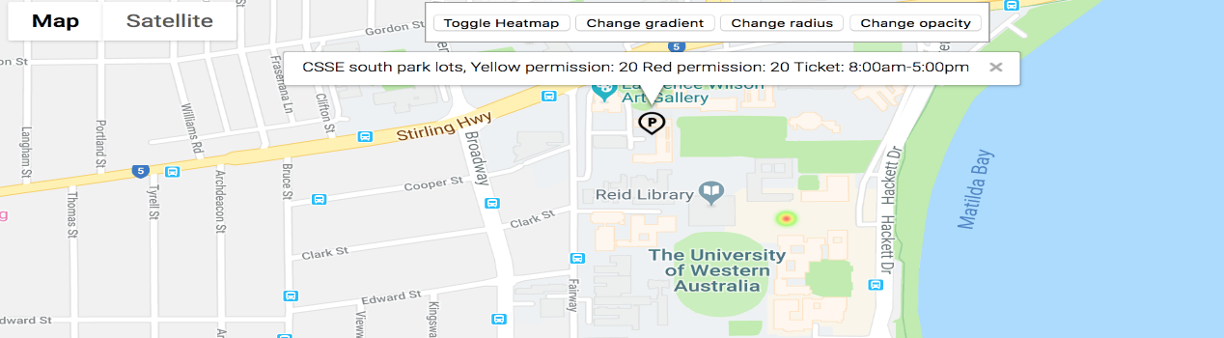1. Heat-map visualization. Using permanent connection instead of keeping refresh the pages. Markers will be made for the administrator heat-map not for users( legal issu

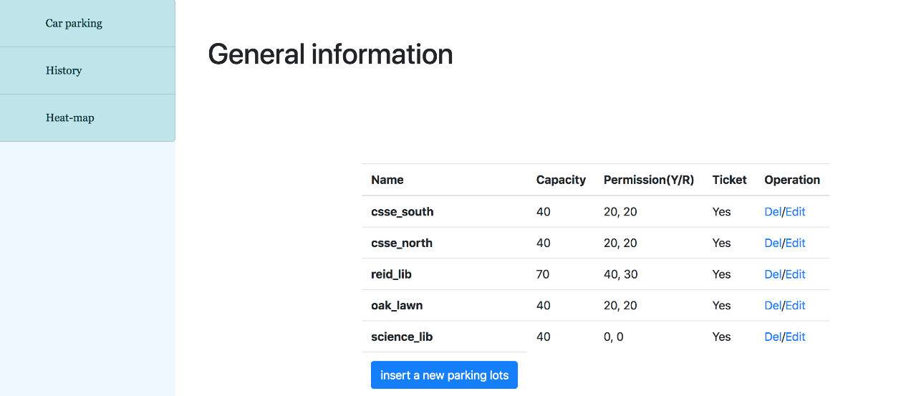2. Administrator management

a. History (Not finished yet, the client asks for bar charts so that admin pages can view general statistic for different kinds of users(i.e student and staff) will be done within a week )

b. Admin CRUD(Create, read, update, delete ) via the website.

1. Back end

Client Question:

1. History statistic display

Bar charts display different types of users, staff and student.

1. Auto-trigger or pushing button

Pushing button will send information to server instead of auto-trigger

1. Shapes solutions?
2. Test framework